1.Grade Checker Program

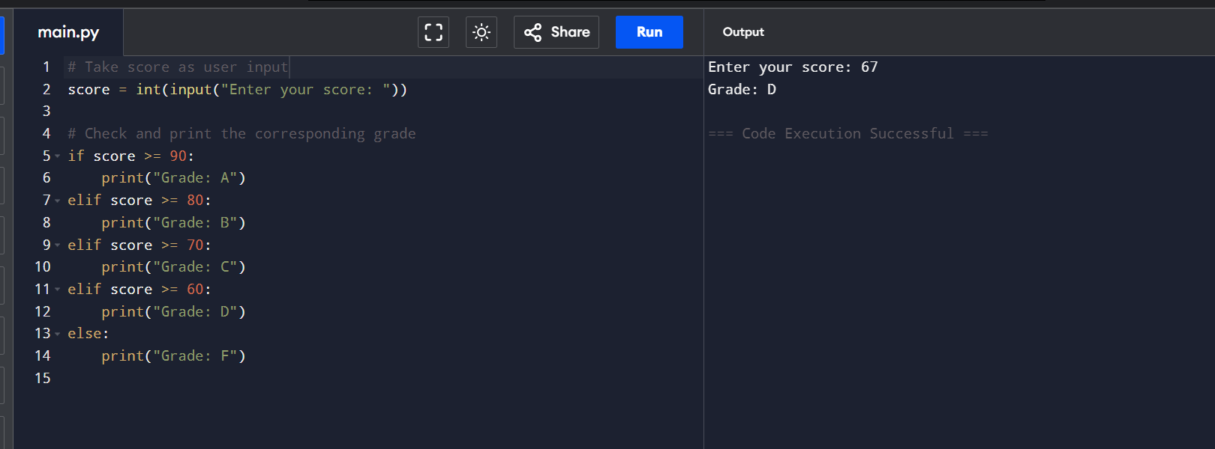

**2.Student Grade  
# Create an empty dictionary to store student names and their grades**

student_grades = {}

**# Start an infinite loop to keep showing the menu until the user chooses to exit**

while True:

**# Display the menu options**

    print("\n--- Menu ---")

    print("1. Add a new student and grade")

    print("2. Update an existing student's grade")

    print("3. Print all student grades")

    print("4. Exit")

**# Ask the user to enter their choice**

    choice = input("Enter your choice (1-4): ")

**# If the user chooses option 1: Add a new student**

    if choice == '1':

**# Ask for the student's name**

        name = input("Enter student name: ")

**# Check if the student already exists in the dictionary**

        if name in student_grades:

            print("Student already exists.")  **# Inform the user if the student is already added**

        else:

**# Ask for the student's grade**

            grade = input("Enter grade: ")

**# Add the student and grade to the dictionary**

            student_grades[name] = grade

            print("Student added.")  **# Confirm addition**

**# If the user chooses option 2: Update an existing student's grade**

    elif choice == '2':

**# Ask for the student's name to update**

        name = input("Enter student name to update: ")

**# Check if the student exists in the dictionary**

        if name in student_grades:

**# Ask for the new grade**

            grade = input("Enter new grade: ")

**# Update the grade in the dictionary**

            student_grades[name] = grade

            print("Grade updated.")  # Confirm update

        else:

            print("Student not found.")  # Inform if student doesn't exist

**# If the user chooses option 3: Print all student grades**

    elif choice == '3':

**# Check if the dictionary is empty**

        if len(student_grades) == 0:

            print("No student data available.")  # Inform if no data

        else:

            print("\n--- Student Grades ---")

**# Loop through the dictionary and print each student's name and grade**

            for name in student_grades:

                print(name + ": " + student_grades[name])

**# If the user chooses option 4: Exit the program**

    elif choice == '4':

        print("Exiting program.")  **# Exit message**

        break  **# Exit the loop and end the program**

**# If the user enters an invalid option**

    else:

        print("Invalid choice. Please enter a number from 1 to 4.")  **# Error message**

**Figure 1:student record added**

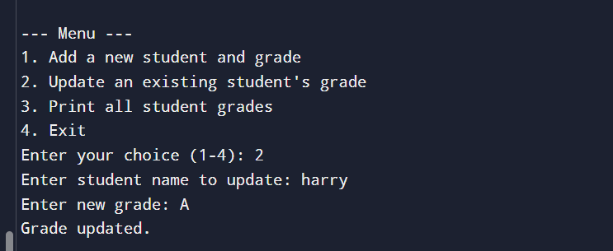

**Figure 2 validation of data exists or not**

Figure 3 grade updation

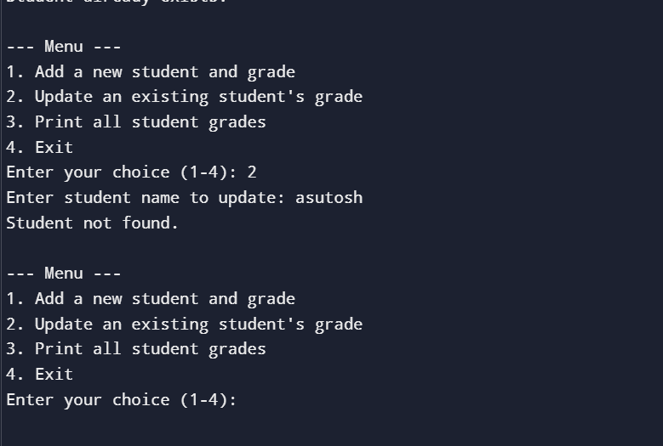

Figure 4 check for invalid student record

Figure 5 check for entering invalid option in the menu

3.Program to create a text file and write content to it

Output  
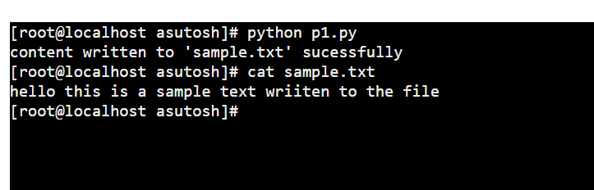

4.Read from a file

O/P  
